# <https://www.youtube.com/watch?v=vhg01Ml-8pI>

advantages native app

* apps do work offline
* fast when opening

disadvantages

* multiple languages
  + 3 platforms
* Expensive
* Sucks to get in store

## Pwa to the rescue

Uses javascript and json

Benefits of native apps including performance

Write once works everywhere

## What does progressive mean

Progressive

* It is just a website whit some added features, if the os doesn’t support a feature the app should not break

## 3 steps to get a web app to a progressive web app

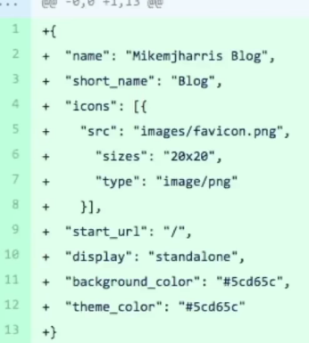**Manifest.json**

* Config you app
* How it appears on the home screen (app icon)
* Colors to use when opening

**Service worker**

javascript

* Proxy server
  + Sits between browser and server
* Manage cache programmatically

Problems with pwa

* Chaching is hard
* Two tabs open can be an issue